
MAYCON CONSTRUCTION MANAGEMENT (2023) LTD.
PO BOX 652 SECHELT POST OFFICE
SECHELT BC V0N 3A0
T:604-886-2500 E: info@maycon.ca

WATERMAIN CLOSURE NOTICE

TO LOCAL RESIDENTS:
CLOSURE 3 (May.12) – DURING THE TIME BETWEEN 8AM-5PM YOU WILL HAVE YOUR WATER TEMPORARILY SHUTDOWN FOR CONSTRUCTION RELATED ACTIVITIES. WE WILL TRY TO MINIMIZE IMPACTS TO YOUR HOME AS BEST POSSIBLE

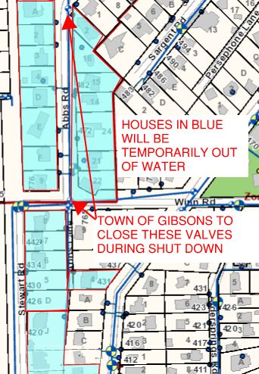
IF YOU HAVE ANY QUESTIONS PLEASE CALL THE NUMBER BELOW.
REGARDS,
ADAM NANSON
MAYCON CONSTRUCTION
604-886-2500

